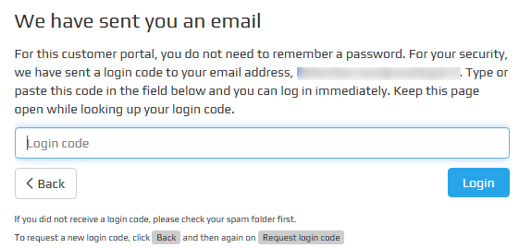
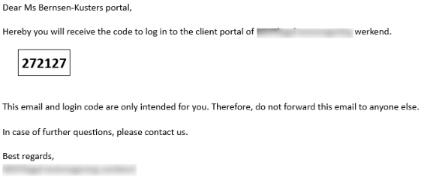
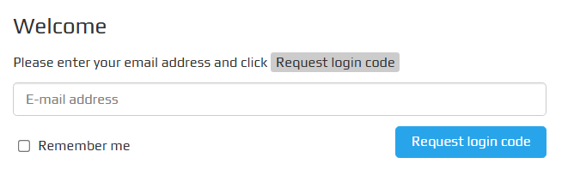




Shows one or more dossiers.
A dossier contains:
- Field “Your reference”: here you can enter your own reference (searchable).
- Progress overview .
- Tab ‘Correspondence’ .
- Tab ‘Documents’ .
- Tab ‘Supplied by me’ .
- Tab ‘Messages’ :
  - Incoming + replied messages* .
  - New outgoing messages from customer*.

*Option to add attachment(s).
One-time login code has been sent
to the specified e-mail address. This code is valid for 10 minutes.

Enter e-mail address
1
2
Request login code
3
Login with code
Dossiers
Actions
Form(s) to be completed.

- This tile is activate immediately after logging in if there are forms that have not been (fully) processed.
Account
Settings.

- Option to set language.

- For legal entities: add additional accounts.

- Option to log out of all logged-in devices at once.
Customer portal

